# Lesson 0 – Introduction

## DESCRIPTION

In this lesson, as well as in further lessons, different icons and font styles guide you and help you get the necessary information in order to complete these lessons.

Important general information



Information on the current chapter



Workflow (what you should do)



Italic *Italic* letters show you the *command* name and *default* settings

**Bold** **Bold** letters show you the active command n

SMALL CAPS Mouse control movements

1. General numeration

Numeration for program work steps



Text Input text to type in

## INSTALLING ArcGIS Pro (ON YOUR PRIVATE COMPUTER)

We will work this semester with ArcGIS Pro. You can either use the public computers in the CIP-Pools (computer labs) or Your private computer to run it.

In the case of using a public computer, ArcGIS Pro is already installed, so You can directly move to 0.3 and 0.4.

If You are using a private computer, please check out the following installation guide. It is worth noting that ArcGIS Pro can only run in a Windows environment.



1. Register at [ArcGIS Online](https://tu-muenchen.maps.arcgis.com/) (https://tu-muenchen.maps.arcgis.com) and select *TUM* under *Enterprise-Anmeldename.*
2. Download the installation file (*.iso) to install ArcGIS Pro at <https://webdisk.ads.mwn.de/?folder=tuwz/q6i/software/tum/stud/esri>   
   (anything from version 3.0 upwards is fine)

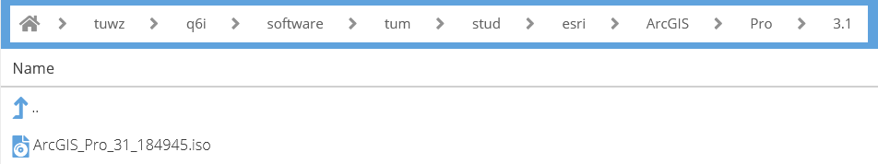

1. After installing it, You can run ArcGIS Pro. Open the program and sign in using the URL *tu-muenchen.maps.arcgis.com* and Your TUM credentials*.* Then, You can move to 0.5.

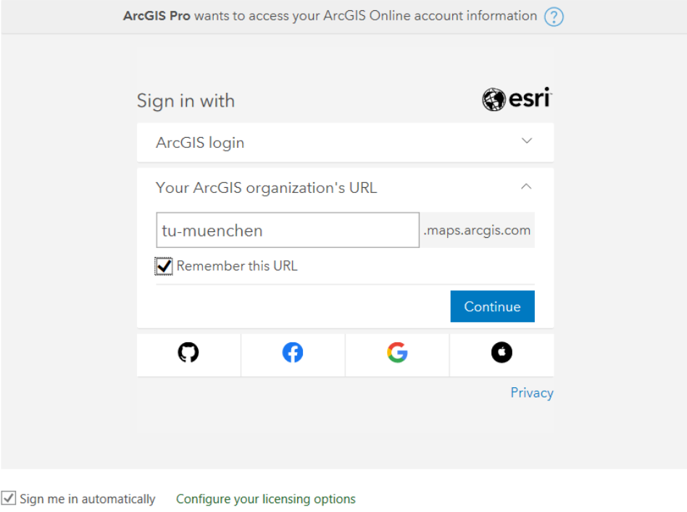

## COMPUTER LOGIN TO TUM PC

You can log in with Your TUM credentials on all computers in the Carto Lab (0712) as well as the other faculty CIP-Pools (3209, 3238, N0199A).

* **Username**: your TUMonline login

**Password**: your TUMonline password

## STARTING ArcGIS Pro



1. If You start ArcGIS Pro for the first time at the TUM, You will have to register at [ArcGIS Online](https://tu-muenchen.maps.arcgis.com/) (<https://tu-muenchen.maps.arcgis.com>) to activate Your student license. Select TUM under *Enterprise-Anmeldename* to log in with Your TUM credentials. If You have already done this before, You can continue with step 2.
2. Run ArcGIS Pro and *Sign in* with the URL *tu-muenchen.maps.arcgis.com*

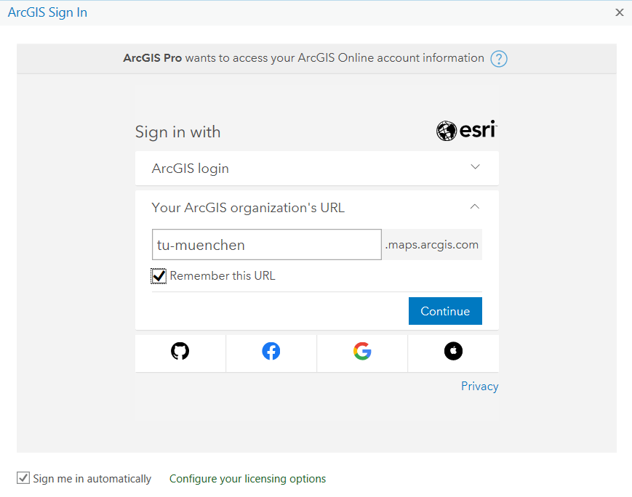

1. ArcGIS will open a browser tab for You to sign in. CLICK the blue TUM button and log in with Your TUM credentials

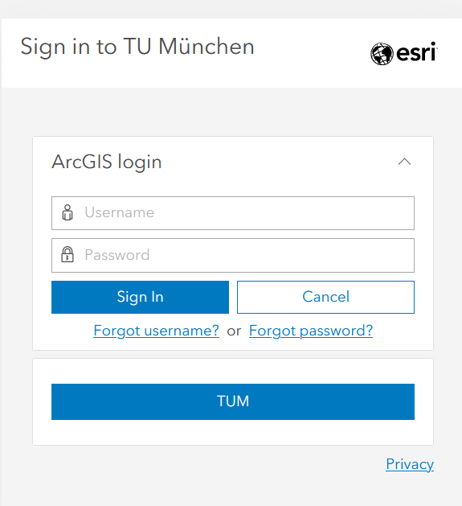

(Confirm occurring script error notices, they should be of no harm.)

## DATA

You will find your data set on Moodle. Copy the *Data Students.gdb* file to your local drive and unzip the file. This geodatabase features all the data You need for the first lessons. Additional data for forthcoming lessons will also be given on Moodle in the coming weeks.

## SAVING YOUR DATA ON TUM PC

Save all of your work on your personal webdisk or on a memory stick only. Your personal webdisk is the drive with Your TUMonline name.



You can access your webdisk from a browser, too. <https://webdisk.ads.mwn.de/>

It is advisable to save all geodata files (*.gdb, *.shp, *.dbf, etc.) and project files (*.aprx) in the same folder. The project file does not feature any geodata!

It’s important to save your work frequently; otherwise, if the program collapses, hours of the work can be destroyed!

* **Save often and frequently under changing file names**

## DIRECTORY AND PATH NAME

Never create directories names that have **spaces**, **dots**, or other **special (non-alphanumeric) characters**, anywhere in the path name for the directory. This can lead to problems in ArcGIS Pro. Instead of spaces, use underscores (“Traffic_Road_Layer”) or Camel styles (“TrafficRoadLayer”).

## STUDY AREA

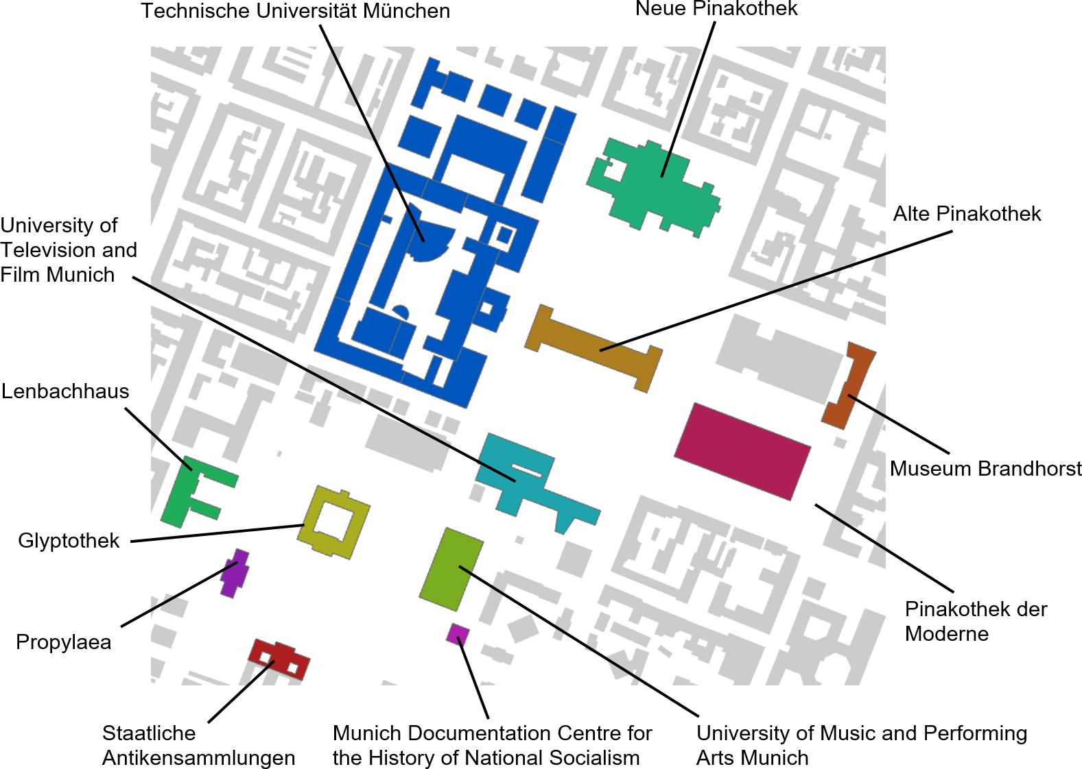

In the next few lessons, we will work with a data set located around the Technical University of Munich, namely [Kunstareal München](https://kunstareal.de/) (art area of Munich). The figure above shows you the building outlines from the test area. The colored buildings are the most famous ones.

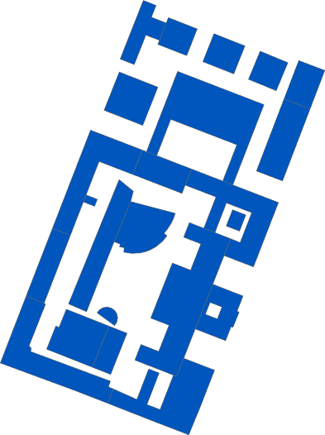

You know this one.

In 1868, King Ludwig the 2nd founded a “Polytechnic School” reorganized like a university. It was awarded the designation “Technical University” in 1877.



**Alte Pinakothek (Old Pinakothek)**

On display are more than 800 paintings, among them numerous well-known masterpieces of 14th to 18th Century European painting.



**Neue Pinakothek (New Pinakothek)**

Offers an overview of European art from classicism to art nouveau.



**Pinakothek der Moderne (Pinakothek of Modern Art)**

It is a Modern Art Museum presenting art, architecture, graphics, and design. One of the world’s greatest collections of 20th and 21st-century modern art.



**Museum Brandhorst**

It displays about 200 exhibits from the collection of modern art of the heirs of the Henkel trust, Udo Fritz-Hermann and Anette Brandhorst.



**Glyptothek**

The Glyptothek was commissioned by the Bavarian King Ludwig I to house his collection of Greek and Roman sculptures.

**Propyläen**



This great gate was created in 1848 as a memorial for the accession to the throne of Otto of Greece, a son of the principal King Ludwig the 1st of Bavaria.

**Lenbachhaus**



This gallery contains a variety of works by Munich painters and contemporary artists in styles such as The Blue Rider and New Objectivity.



**University of Television and Film Munich**

The University of Television and Film Munich (German: Hochschule für Fernsehen und Film München, short: HFF Munich) is a publicly funded film school.

It is one of Germany’s most reputable film schools, with about 350 students enrolled.

**NS-Dokumentationszentrum München**



**(Munich Documentation Centre for the History of National Socialism)**

The Munich Documentation Centre for the History of National Socialism (NS-Dokumentationszentrum) is a museum which focuses on the history and consequences of the Nazi regime and the role of Munich as Hauptstadt der Bewegung (′capital of the movement′).



**University of Music and Performing Arts Munich**

The University of Music and Performing Arts Munich (German: Hochschule für Musik und Theater München) is one of the most respected traditional vocational universities in Germany, specializing in music and the performing arts.

**Staatliche Antikensammlungen**



**(State Collections of Antiquities)**

It is a museum holding Bavaria's collections of antiquities from Greece, Etruria, and Rome.